1**.We have many open source tools/technologies to process huge datasets. Give 4 tools?**

**2.What is difference between data analyst and data scientist? [1]**

* **Data Scientist is someone who can predict the future based on past patterns (roles involve estimating the unknown)**
* **Data analyst is someone who merely curates’ meaningful insights from data (who do the day-to-day analysis stuff but data scientists have the what-ifs)**

**3.What is data visualization? and give some tools of data visualization [2]**

* **Data visualization is the presentation of data in a pictorial or graphical format.**
* **Enable Decision-makers to see analytics presented visually (grasp difficult concepts/Identify new patterns).**
* **Tools of Data Visualization:**

**4.Why data visualization is important for business decisions? [2]**

* **Visualizing of complex data easier with Using charts/graphs.**
* **Convey concepts in a universal manner quickly and easer.**
* **Identify areas require attention/improvement.**
* **Clarify which factors influence customer behavior.**
* **Understand to place products.**
* **Predict sales volumes.**

**5. Install R in your computer.**

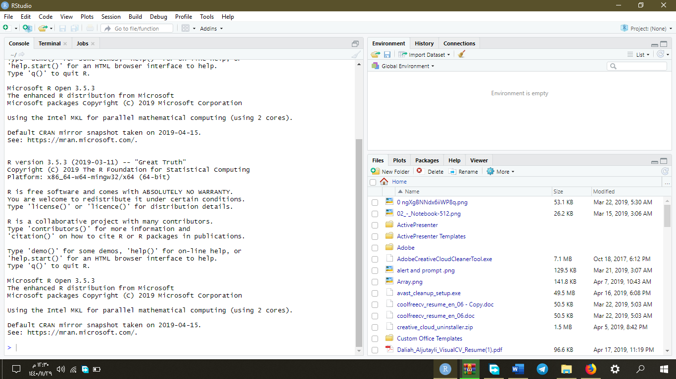

**6. Learn basic of R language then Enjoy with R!! “ Try to do any code , you can create a vectors , draw curve, read data from csv file, etc ... “ (Screenshot)**

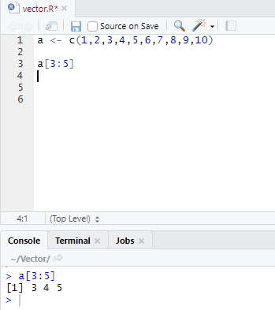

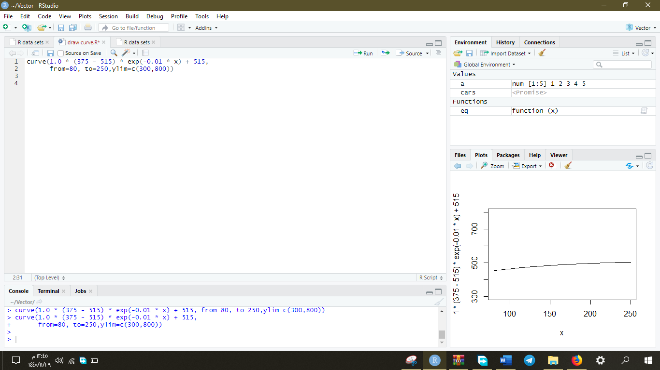

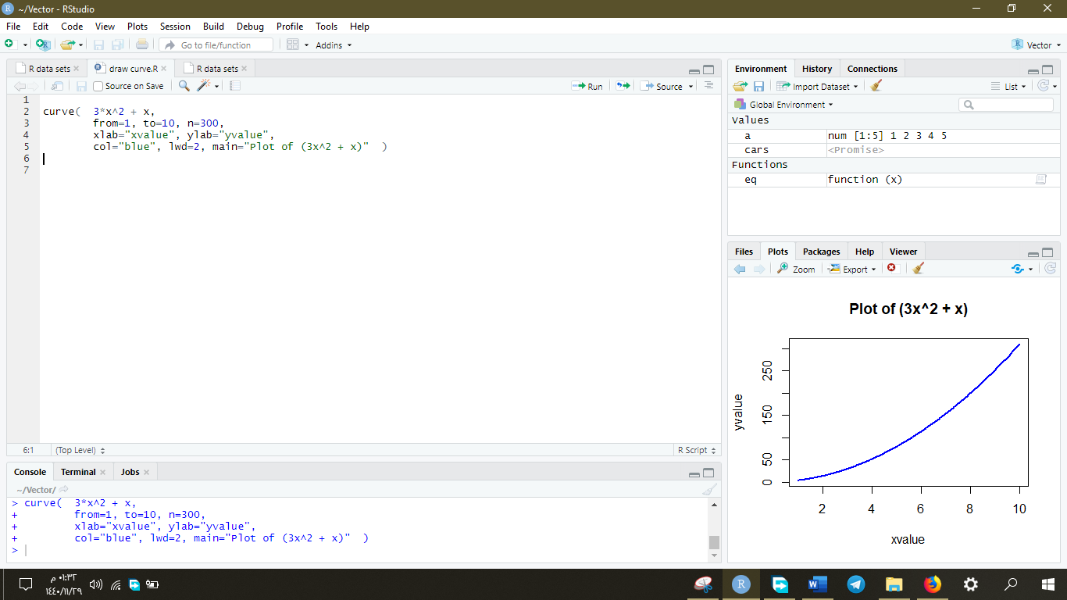

**Read CSV File:**

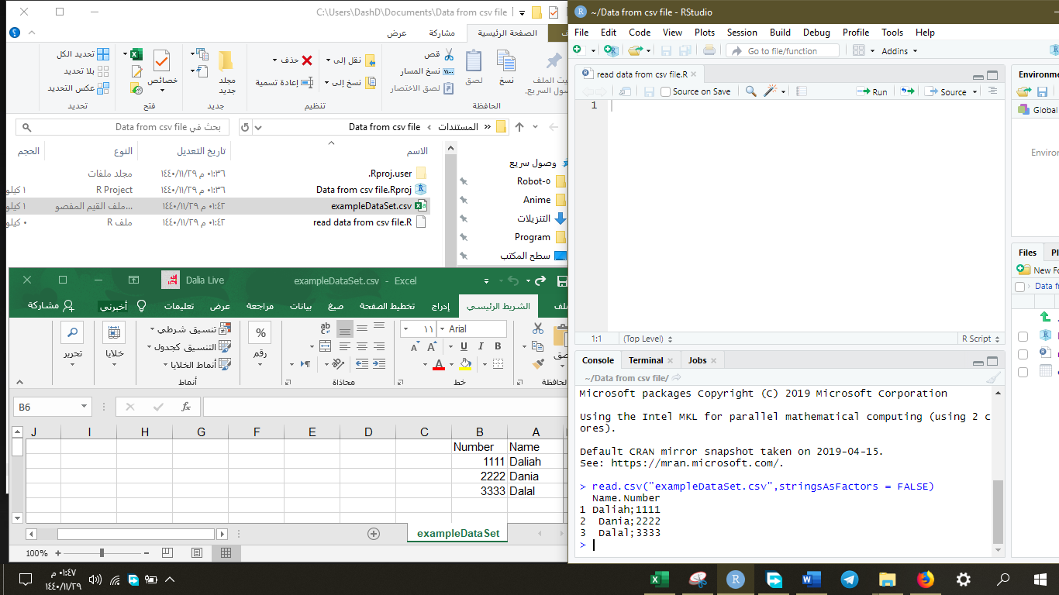

[1]"Difference between Data Analyst and Data Scientist", *DeZyre*, 2019. [Online]. Available: https://www.dezyre.com/article/difference-between-data-analyst-and-data-scientist/332. [Accessed: 01- Aug- 2019].

[2]"Απεικόνιση Δεδομένων", *Sas.com*, 2019. [Online]. Available: https://www.sas.com/el_gr/insights/big-data/data-visualization.html. [Accessed: 01- Aug- 2019].